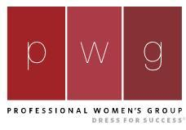

A program of

Member Vision Statement: “Inspire women through professionalism, where self-defined success is achieved in career and life in a multi-cultural environment.”

Professional Women’s Group, ’PWG’, is an exclusive career development alliance for women who obtain employment following services at Dress for Success Columbus. Meetings are hosted monthly; topics focus on various aspects of Professional Development. Membership is free of charge. Certificates of Achievement awarded annually.

Please contact our Dress for Success Columbus Director of Career Development D. Malone via email at columbuspwg@dressforsuccess.org, or telephone at (614) 291-5420 ext 12 to set up an appointment to discuss how PWG can benefit YOU!

Additional information about Dress for Success Columbus is available on our website, www.dfscmh.org.
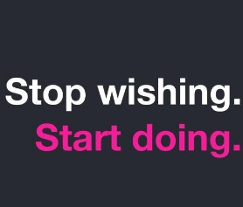
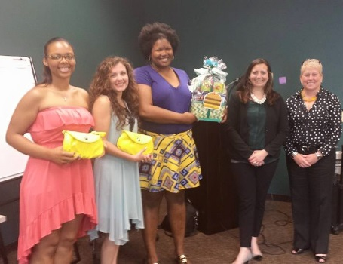
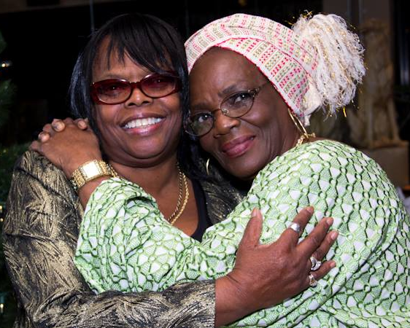

Follow Us On Facebook! Group Name: Professional Women’s Group Columbus

PWG/Professional Women’s Group is a program of Dress for Success Columbus, a non-profit organization. The mission of Dress for Success Columbus is to empower women to achieve economic independence by providing a network of support, professional attire, and career development tools to help women thrive in work and in life. Please visit our website at www.dfscmh.org for more information and program details. Thank you!

